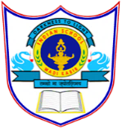
INDIAN SCHOOL AL WADI AL KABIR
Post Mid Term Examination 2022-23
Date: 8/12/2022 SUB: Social Science. Time Allowed: 1 hour
Class: VI Maximum Marks: 30

General Instructions:-
1. Ensure that you have written your name and roll number correctly.
2. This Question paper has three parts, Section A (History) B (Civics) C (Geography).
3. All questions are compulsory
4. All the answers must be correctly numbered as in the question paper in the Answer sheet
provided.
Q.No. | SECTION- A (HISTORY) | 10 Marks
I | Multiple Choice Questions: - | 3 Marks
1 | The ______ was the central figure in the rituals.  (a) Raja (b) |Charioteer (c) Herders (d) Traders | 1 Mark
2 | The tax on produce was called as ____________.  (a) Ghana (b) Gift (c) Dasi (d) Bhaga | 1 Mark
3 | _________ in Bihar was the capital of Magadha for several years.  (a) Meerat (b) Vajji (c) Vaishali (d) Rajagriha | 1 Mark
II | Answer the following in one sentence: - | 2 Marks
4 | How did the rivers help Magadha? | 1 Mark
5 | Which groups could not participate in the assemblies of the ‘ganas’? | 1 Mark
III | Answer the following:- | 2 Marks
6 | What is a ‘Gana’? Name the religious leaders who belonged to the ganas.
IV | Answer in Brief:- | 3 Marks
7 | Why did the rulers of ‘mahajanapadas’ build forts?
 | SECTION- B (CIVICS) | 10 Marks
V | Multiple Choice Questions: - | 2 Marks
8 | ___________ is the language that the Whites spoke.  a) English b) Zulu c) Afrikaans d) None of these | 1 Mark
9 | The leader of the African National Congress was ___________.  a) Nelson Mandela b) Vinni Mandela c) Yasar Arafat d) Kofi Annan. | 1 Mark
VI | Answer the following in one sentence: - | 1 Mark
10 | What do you mean by apartheid?
VII | Answer the following: - | 4 Marks
11 | Who was Hector? What did he want? | 2 Marks
12 | How would Maya’s life be different in South Africa today? (any 2 points) | 2 Marks
VIII | Answer in brief:- | 3 Marks
13 | What actions does the government take to ensure that all people are treated equally?
 | SECTION- C (GEOGRAPHY) | 10 Marks
IX | Fill in the blanks: - | 2 Marks
1 | The ________ Ocean is named after a country. | 1 Mark
2 | ________ is the world’s longest mountain range. | 1 Mark
X | Answer the following in one sentence: - | 1 Mark
3 | Why the earth is called as the ‘blue planet’?
XI | Answer the following: - | 4 Marks
4 | Name the major continents of the earth. | 2 Marks
5 | Observe the diagram and label the parts marked as ‘A’ and ‘B’.  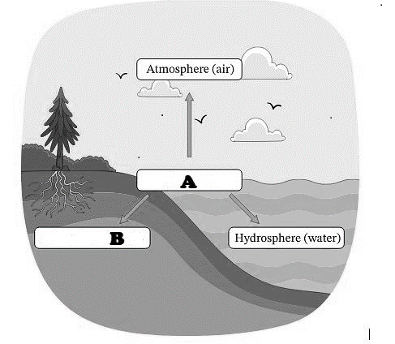 | 2 Marks
XII | Answer in brief:- | 3 Marks
6 | What are the main components of the ‘Environment’?

